

Vector Data Base

[Document subtitle]



[Date]

Team

**Comprehensive Research on Vector Databases (Vector DBs)**

**Revolutionizing Data Search and Retrieval in AI-Powered Applications**

Contents

**Table of Contents**

1. **Introduction**
2. **What are Vector Databases?**
   * 2.1 Definition and Functionality
   * 2.2 Embeddings and Their Role
3. **Types of Vector Databases**
4. **Vector Databases vs Traditional Databases**
   * 4.1 Differences in Data Storage and Query Mechanisms
   * 4.2 Performance Comparisons
5. **Advantages of Vector Databases**
6. **Disadvantages of Vector Databases**
7. **Vector Database Solutions** 
   * 7.1 Milvus
   * 7.2 FAISS
   * 7.3 Pinecone
   * 7.4 Weaviate
   * 7.5 Vespa
8. **Comparison of Popular Vector Databases**
9. **Implementation Roadmap**
   * 9.1 Choosing the Right Vector Database
   * 9.2 Best Practices for Implementation
   * 9.3 Maintenance and Monitoring
10. **Challenges and Future Directions**
11. **References**

**1. Introduction**

In the era of machine learning, AI, and deep learning, **Vector Databases** (Vector DBs) have emerged as critical components for efficiently storing and retrieving high-dimensional data representations, known as embeddings. Unlike traditional databases, vector databases are optimized for similarity searches, allowing systems to retrieve relevant data points based on context, proximity, or other dimensions.

This document provides a comprehensive overview of vector databases, exploring their benefits, limitations, types, and practical use cases across industries.

**2. What are Vector Databases?**

**2.1 Definition and Functionality**

A **vector database** is a specialized database designed to store, index, and retrieve high-dimensional vectors or embeddings. These embeddings, often generated by machine learning models, are used to represent various data types like text, images, videos, and more. Instead of keyword-based matching (as in traditional databases), vector databases utilize similarity measures, such as cosine similarity or Euclidean distance, to perform searches.

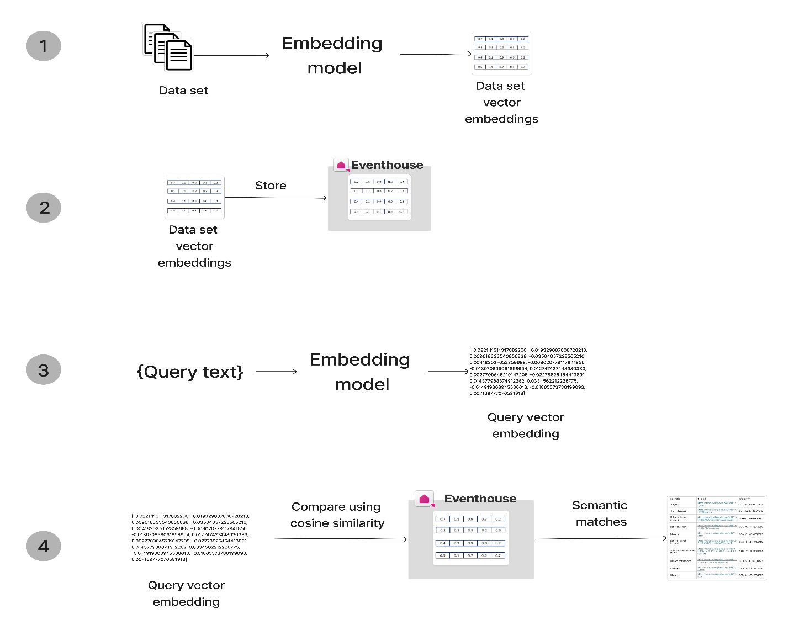

The general workflow for using a vector database is as follows:

1. **Embed data**: Convert data into vector format using an embedding model.
2. **Store vectors**: Store the embedded vectors in a vector database.
3. **Embed query**: Convert the query data into vector format using the same embedding model used to embed the stored data.
4. **Query vectors**: Use vector similarity search to find entries in the database that are similar to the query.

**2.2 Embeddings and Their Role**

Embeddings are mathematical representations of objects (e.g., words, images) in a multi-dimensional space. Vector databases are specifically designed to manage these embeddings, optimizing search and retrieval for tasks such as:

* Semantic search
* Recommendation systems
* Question-answering systems (Q&A)
* Image or video retrieval

**3. Types of Vector Databases**

Vector databases can be classified into two main categories:

* **Standalone Vector Databases:**
  + Designed explicitly for managing and searching vectors.
  + Example: Milvus, Pinecone.
* **Hybrid Databases:**
  + Combine traditional relational database features with vector search capabilities.
  + Example: Vespa, Elasticsearch with vector extensions.

Vector databases can be broadly classified into two main categories based on their architecture and intended use cases: **Standalone Vector Databases** and **Hybrid Databases**. Each category has its own strengths and is suited for different scenarios.

**3.1 Standalone Vector Databases**

**Standalone Vector Databases** are designed explicitly for managing, indexing, and searching high-dimensional vectors. They are optimized for similarity search tasks and are often used in applications involving large-scale, unstructured data.

**3.1.1 Milvus**

* **Description:** Milvus is an open-source vector database designed for high-performance similarity search and analytics of vector embeddings. It supports both exact and approximate nearest neighbor search and is highly scalable.
* **Advantages:**
  + Scalable and supports large-scale vector searches.
  + Flexible with indexing methods for various search requirements.
* **Disadvantages:**
  + Requires initial setup and configuration.
  + Limited support for traditional relational operations.

**3.1.2 Pinecone**

* **Description:** Pinecone is a managed vector database service that provides real-time search and recommendation capabilities. It automatically handles scaling and infrastructure management, making it easy to integrate with various applications.
* **Advantages:**
  + Managed service with automatic scaling and maintenance.
  + Simple API for quick integration and deployment.
* **Disadvantages:**
  + Higher cost for large-scale deployments.
  + Limited control over the underlying infrastructure.

**3.2 Hybrid Databases**

**Hybrid Databases** combine the features of traditional relational databases with vector search capabilities. They provide a way to perform vector searches while also handling structured data queries.

**3.2.1 Vespa**

* **Description:** Vespa is an open-source search engine and data processing platform that integrates vector search capabilities with traditional search features. It supports a variety of data types and search functionalities.
* **Advantages:**
  + Integrates vector search with traditional search features.
  + Flexible and supports various data types and query operations.
* **Disadvantages:**
  + Can be complex to set up and configure.
  + May require additional infrastructure management.

**3.2.2 Elasticsearch with Vector Extensions**

* **Description:** Elasticsearch is a widely used search engine that can be extended to support vector search capabilities. Extensions or plugins enable Elasticsearch to handle high-dimensional vector queries alongside traditional search functionalities.
* **Advantages:**
  + Combines traditional search with vector search capabilities.
  + Well-documented and widely used.
* **Disadvantages:**
  + Requires additional setup for vector search.
  + Performance may vary based on implementation and scale.

**4. Vector Databases vs Traditional Databases**

This section provides an overview of different types of vector databases, showcasing how each can be utilized effectively based on specific use cases and requirements. Each database type offers unique advantages and is suited for different scenarios, from standalone vector search to hybrid solutions that combine traditional and vector-based searches.

**4.1 Differences in Data Storage and Query Mechanisms**

* **Traditional Databases:**
  + Use relational or NoSQL models.
  + Store data as structured tables or documents.
  + Queries rely on exact matching, filtering, and sorting.
* **Vector Databases:**
  + Store high-dimensional vectors as embeddings.
  + Use similarity-based searches (e.g., nearest neighbor search).
  + Optimize for approximate nearest neighbor (ANN) algorithms, such as HNSW, PQ, or IVF.
  + Comparison

| **Aspect** | **Vector Databases** | **Traditional Databases** |
| --- | --- | --- |
| **Data Type** | Unstructured data (text, images, audio, embeddings) | Structured data (tables, rows, columns) |
| **Data Format** | High-dimensional vectors (e.g., 512-dimensional embeddings) | Numerical, string, date, and relational data |
| **Query Type** | Nearest Neighbor Search (semantic similarity) | SQL-based queries (relational, filtering, joins) |
| **Indexing** | Optimized for vector search (ANN, IVF, PQ) | B-trees, hash tables, indexing for fast lookups and joins |
| **Usage** | AI, ML, search engines, recommendation systems | Transaction processing, analytics, data warehousing |
| **Performance** | High-dimensional search (approximate or exact) | Optimized for ACID transactions and OLAP queries |
| **Scaling** | Designed for massive-scale unstructured data | Suitable for structured data with relational integrity |
| **Flexibility** | Schema-free or schema-light, adaptable to AI models | Fixed schema with relational constraints |
| **Cost Efficiency** | Generally, requires more computational resources for queries | Efficient for simple transactional operations |
| **Integration with AI** | Deep integration with machine learning models (LLMs, NLP) | Limited direct integration with machine learning workflows |
| **Example Use Cases** | Image search, semantic search, recommendation engines | Financial transaction processing, inventory management |

**4.2 Example Use Cases**

**4.2.1 Product Recommendations**

* **Traditional Database Solution:**
  + **Scenario:** Recommending products based on purchase history.
  + **SQL Query Example:** Uses collaborative filtering based on historical transactions.
* **Vector Database Solution:**
  + **Scenario:** Recommending products based on semantic similarity of product descriptions.
  + **Example Code:** Utilizes vector embeddings for semantic similarity search.

**4.2.2 Fraud Detection**

* **Traditional Database Solution:**
  + **Scenario:** Detecting outliers in transaction amounts.
  + **SQL Query Example:** Filters transactions based on statistical thresholds.
* **Vector Database Solution:**
  + **Scenario:** Detecting fraudulent transactions using semantic embeddings of transaction descriptions.
  + **Example Code:** Uses vector embeddings to identify anomalies in transaction patterns.

**4.3 Performance Comparisons**

* **Speed:**  
  Vector databases are optimized for fast, real-time searches even with large datasets.
* **Search Quality:**  
  Traditional databases work well for structured, exact-match queries, while vector databases excel in finding similar results based on context or proximity.

**5. Advantages of Vector Databases**

1. **High-Dimensional Search:**
   * Optimized for similarity searches in large, unstructured datasets.
   * Excellent for applications like semantic search and recommendation engines.
2. **Real-Time Performance:**
   * Fast response times for complex queries, even with billions of vectors.
3. **Scalability:**
   * Easily handle large-scale data across distributed systems.
4. **Support for AI/ML Workflows:**
   * Seamlessly integrates with machine learning pipelines for tasks like natural language processing (NLP), image search, and question-answering systems.

**6. Disadvantages of Vector Databases**

1. **Complexity:**
   * More complex to implement and maintain compared to traditional databases.
2. **Approximation Errors:**
   * Vector databases often rely on Approximate Nearest Neighbor (ANN) algorithms, which may introduce minor inaccuracies in search results.
3. **Resource-Intensive:**
   * High resource demands for indexing and querying, especially with larger datasets.
4. **Limited Query Flexibility:**
   * Vector databases are highly specialized and may not handle complex relational queries like traditional databases.

**7. Vector Database Solutions**

**7.1 Milvus**

* **Description:** An open-source vector database designed to manage embeddings for various AI applications.
* **Key Features:** Distributed architecture, support for multiple indexing algorithms (HNSW, IVF).
* **Use Cases:** Semantic search, recommendation engines, anomaly detection.

**Overview**: Milvus is an open-source vector database designed for high-performance similarity searches and large-scale analytics. It supports a wide range of indexing methods.

**Use Case: Semantic Search for E-Commerce**

**Scenario**: The e-commerce platform wants to index product descriptions and retrieve similar products based on a user query.

**Code Example:**

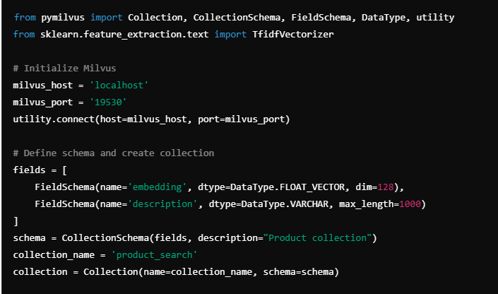

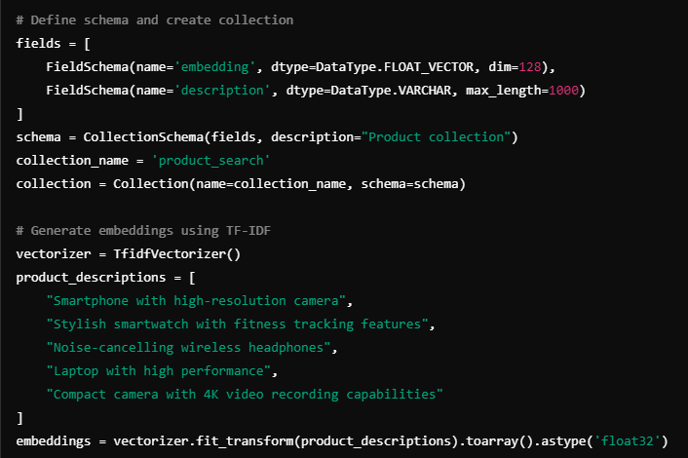

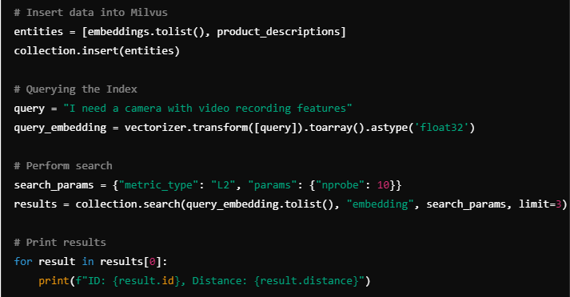

**Advantages**:

* Open-source with high customizability.
* Suitable for large-scale operations.

**Disadvantages**:

* Requires manual setup and maintenance of infrastructure.
* Learning curve for advanced features.

**7.2 FAISS (Facebook AI Similarity Search)**

* **Description:** A library for efficient similarity search and clustering of dense vectors.
* **Key Features:** Fast approximate nearest neighbor search with state-of-the-art performance.
* **Use Cases:** Image search, clustering, NLP tasks.

**Overview**: FAISS (Facebook AI Similarity Search) is a library optimized for efficient similarity search on high-dimensional vectors. It's highly flexible and works well for large datasets.

**Use Case: Semantic Search for E-Commerce**

**Scenario**: The e-commerce platform wants to implement semantic search for product recommendations by indexing product embeddings and performing similarity searches.

**Code Example:**

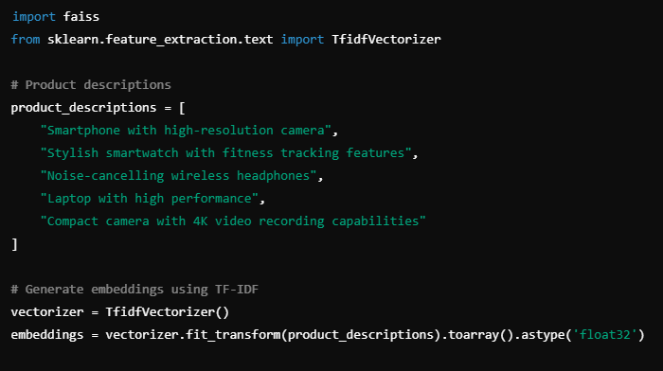

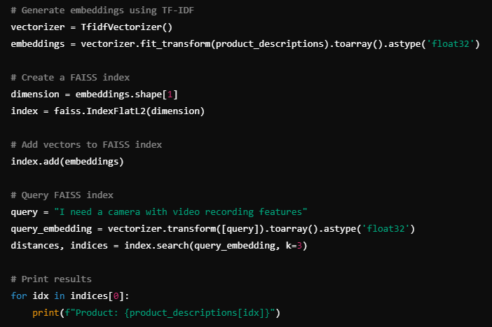

**Advantages**:

* Extremely fast and optimized for large-scale searches.
* Wide range of indexing and search algorithms.

**Disadvantages**:

* Requires more manual setup and maintenance.
* Lacks built-in cloud or scaling features.

**7.3 Pinecone**

* **Description:** A managed vector database service that provides fast and scalable vector searches without the complexity of infrastructure management.
* **Key Features:** Real-time search, scaling, and easy integration with ML pipelines.
* **Use Cases:** Personalized recommendations, question answering, content-based retrieval.

**Overview**: Pinecone is a fully managed vector database optimized for production applications. It offers scalability and high performance without needing to manage infrastructure.

**Use Case: Semantic Search for E-Commerce**

**Scenario**: An e-commerce platform wants to implement a product recommendation system based on semantic similarity between product descriptions and user queries.

**Code Example:**

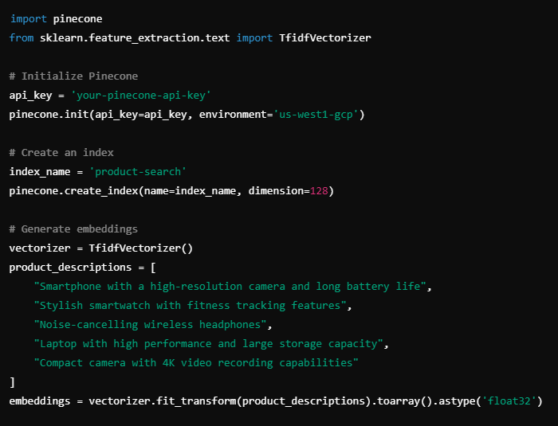

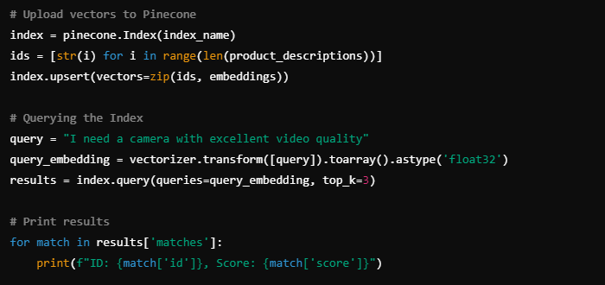

**Advantages**:

* Easy to scale.
* Managed infrastructure with real-time performance.

**Disadvantages**:

* Managed service, leading to vendor lock-in.
* Costs can escalate with large datasets.

**7.4 Weaviate**

* **Description:** An open-source, cloud-native vector search engine with built-in machine learning models.
* **Key Features:** Schema-free data, hybrid search, real-time results.
* **Use Cases:** Contextual search, hybrid queries (combining vector and relational data).
* **Overview**: Weaviate is an open-source vector search engine with built-in support for semantic search, machine learning, and hybrid search features.
* Use Case: Semantic Search for E-Commerce
* **Scenario**: The e-commerce platform wants to enable semantic search using Weaviate to find similar products based on the user's query.

**Code Example:**

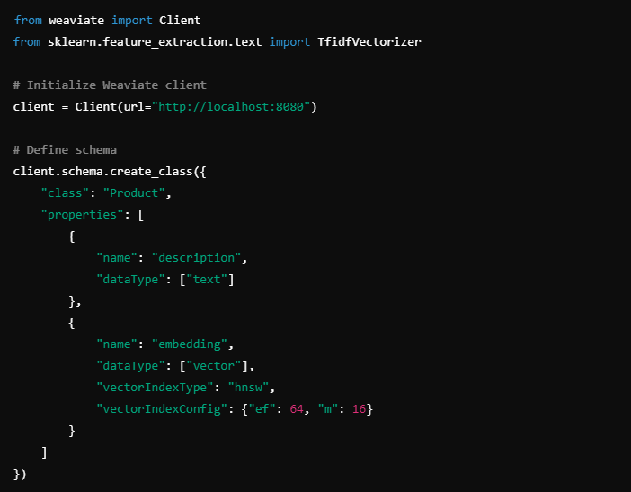

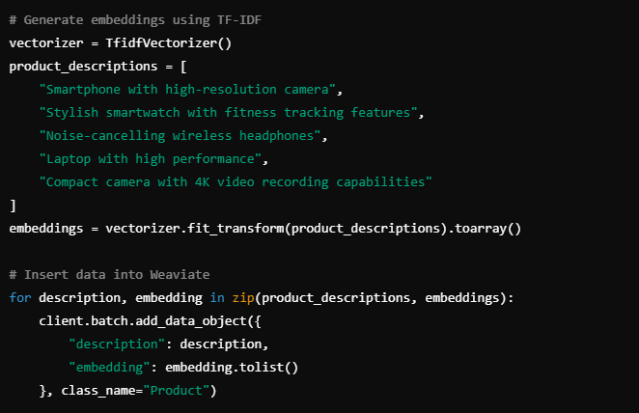

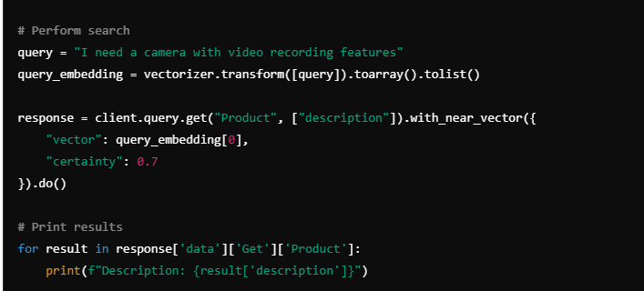

**Advantages**:

* Integrates traditional and vector search features.
* Schema-free and easy to use.

**Disadvantages**:

* Performance may vary depending on configurations.
* Higher setup complexity than fully managed services like Pinecone.

**7.5 Vespa**

* **Description:** A hybrid search engine that supports both traditional and vector-based queries.
* **Key Features:** Schema flexibility, fast vector search, integration with existing data pipelines.
* **Use Cases:** E-commerce product search, multimedia retrieval, fraud detection.

**Use Case: Semantic Search for E-Commerce**

**Scenario**: The e-commerce platform needs to index product descriptions and perform semantic search based on user queries. Vespa will handle both vector search and traditional search requirements.

**Steps to Implement:**

1. **Set Up Vespa**: Install Vespa and create a configuration for the application.
2. **Define Schema**: Create a schema to handle product data and embeddings.
3. **Generate Embeddings**: Use a pre-trained model to convert product descriptions into vectors.
4. **Index Data**: Upload the vectors and product data into Vespa.
5. **Perform Search**: Query the Vespa index to retrieve similar products.

**Detailed Example:**

**1. Set Up Vespa**

First, install Vespa on server or use a Vespa cloud instance.

**2. Define Schema**

Create a schema configuration file (schema.sd) to define the structure of the data:

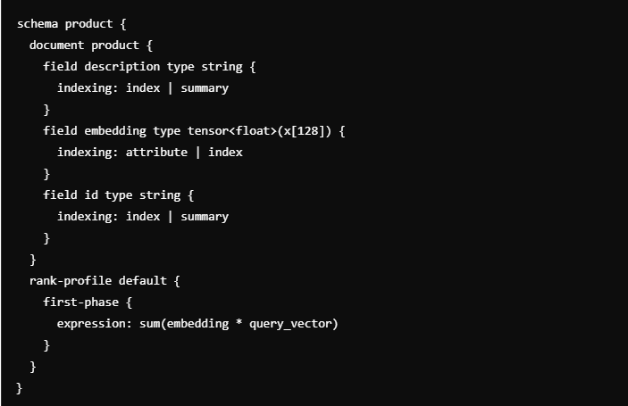

**3. Generate Embeddings**

Use a pre-trained model (e.g., TF-IDF, Word2Vec, BERT) to generate embeddings. For simplicity, we'll use TF-IDF embeddings in this example:

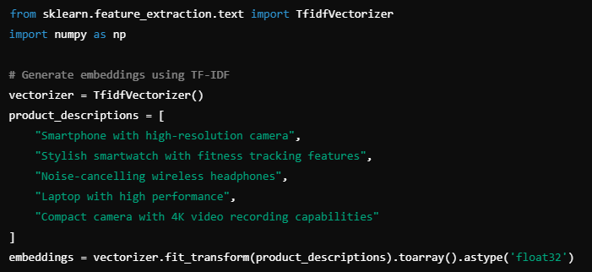

**4. Index Data**

Upload the product descriptions and embeddings to Vespa:

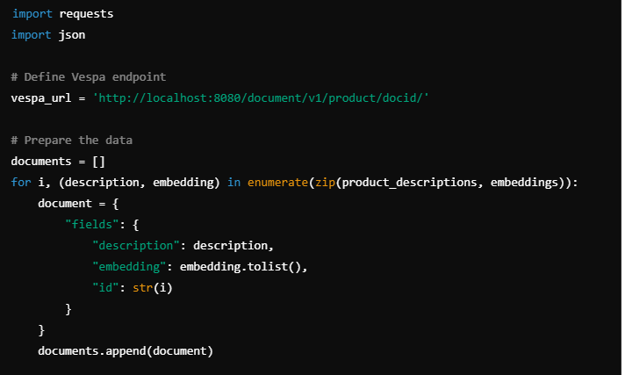

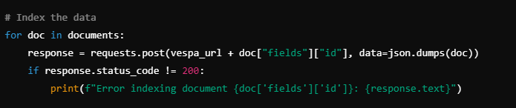

**5. Perform Search**

Query Vespa for similar products based on a user query:

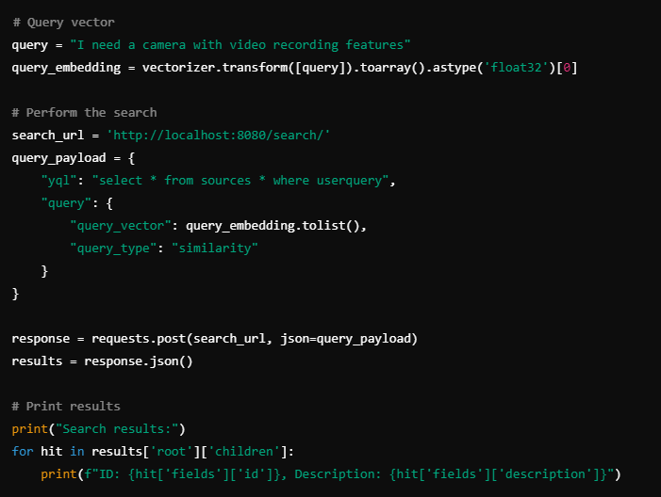

**Advantages:**

* Combines traditional search with vector search.
* Real-time indexing and low-latency queries.
* Highly customizable and scalable.

**Disadvantages:**

* Requires more initial setup and maintenance.
* Learning curve for complex configurations.

**8. Comparison of Popular Vector Databases**

| **Database** | **Open-Source** | **Managed Service** | **Indexing Algorithms** | **Use Case Suitability** | **Scalability** |
| --- | --- | --- | --- | --- | --- |
| **Milvus** | Yes | No | HNSW, IVF | General purpose AI/ML | High |
| **FAISS** | Yes | No | PQ, IVF, HNSW | Image and NLP tasks | Medium |
| **Pinecone** | No | Yes | Proprietary | Real-time, managed service | Very High |
| **Weaviate** | Yes | Yes | HNSW | Semantic search, hybrid | High |
| **Vespa** | Yes | No | Custom | Hybrid queries | Medium |

**9. Implementation Roadmap**

**9.1 Choosing the Right Vector Database**

* **Assess Use Case:** Consider specific requirements like speed, accuracy, scalability, and the nature of data.
* **Indexing Algorithm:** Select appropriate indexing methods (HNSW, IVF, PQ) based on performance needs.
* **Cloud vs On-Premise:** Decide between managed services (e.g., Pinecone) for ease of use or open-source (e.g., Milvus, FAISS) for greater control.

**9.2 Best Practices for Implementation**

* **Data Preprocessing:** Ensure embeddings are generated efficiently using high-quality models (e.g., BERT, GPT, CLIP).
* **Index Optimization:** Regularly update indexes to reflect new data for optimal search performance.
* **Hybrid Query Design:** Combine traditional filters with vector-based search for better query flexibility.

**9.3 Maintenance and Monitoring**

* **Monitor Latency:** Regularly track query response times to avoid performance degradation.
* **Scaling:** Ensure appropriate scaling strategies, especially for distributed architectures, to handle growing datasets.
* **Continuous Updates:** Refresh embeddings as new data or improved models become available.

Choosing the best vector database among Pinecone, Milvus, FAISS, Weaviate, and Vespa depends on specific project requirements, including factors like scalability, ease of use, performance, and integration capabilities. Here’s a summary to help determine which might be the best fit for different scenarios:

**1. Pinecone**

**Best For**:

* **Ease of Use**: Pinecone is a fully managed service that requires minimal setup and maintenance, making it ideal for teams who want to focus on development rather than infrastructure.
* **Scalability**: It scales effortlessly, handling large datasets and high query volumes with real-time performance.

**Consider If**:

* we prefer a managed solution that abstracts away infrastructure concerns.
* Cost is not a primary constraint and we are willing to pay for convenience and scalability.

**Strengths**:

* Managed service with minimal maintenance.
* High performance and real-time capabilities.

**Weaknesses**:

* Potentially higher costs with large scale.
* Vendor lock-in.

**2. Milvus**

**Best For**:

* **High Performance and Customization**: Milvus offers high performance and flexibility, making it suitable for large-scale applications with specific requirements.
* **Open-Source**: If we need a customizable, open-source solution, Milvus is a strong choice.

**Consider If**:

* we have the resources to manage and maintain our own infrastructure.
* we need advanced features and high-performance search.

**Strengths**:

* Scalable and high performance.
* Open-source with extensive customization options.

**Weaknesses**:

* Requires setup and ongoing maintenance.
* Learning curve for complex configurations.

**3. FAISS**

**Best For**:

* **Speed and Flexibility**: FAISS excels in speed and flexibility for similarity search on large datasets. It's best for applications requiring high-performance vector searches.
* **Integration with Custom Solutions**: Ideal for integration into custom solutions where we manage the infrastructure.

**Consider If**:

* we need an optimized, fast solution for similarity search.
* we are comfortable managing our infrastructure and implementing solutions on top of FAISS.

**Strengths**:

* Extremely fast and efficient.
* Highly customizable.

**Weaknesses**:

* Requires manual setup and maintenance.
* Lacks built-in cloud features and scaling.

**4. Weaviate**

**Best For**:

* **Hybrid Search Capabilities**: Weaviate supports both vector search and traditional search, offering flexibility for applications needing a combination of search types.
* **Ease of Integration**: Provides a schema-free setup and is easy to integrate with existing systems.

**Consider If**:

* we need a hybrid search engine combining vector and traditional search.
* we prefer an open-source solution with built-in semantic search capabilities.

**Strengths**:

* Combines traditional and vector search.
* Schema-free and easy integration.

**Weaknesses**:

* Performance may vary with complex queries.
* More setup complexity compared to managed services.

**5. Vespa**

**Best For**:

* **Real-Time Big Data Applications**: Vespa is optimized for real-time search and analytics at scale, making it suitable for applications requiring high-speed and high-volume data handling.
* **Customization and Scalability**: Offers extensive customization and scalability for complex use cases.

**Consider If**:

* we need real-time big data search capabilities.
* we have the resources to manage and maintain the infrastructure.

**Strengths**:

* Real-time search with high scalability.
* Customizable and flexible.

**Weaknesses**:

* Requires significant setup and maintenance.
* Steeper learning curve.

**Summary**

* **Pinecone**: Best for ease of use, managed services, and scalability.
* **Milvus**: Best for high performance and customization with open-source flexibility.
* **FAISS**: Best for speed and flexibility in similarity search.
* **Weaviate**: Best for hybrid search capabilities and easy integration.
* **Vespa**: Best for real-time big data search and extensive customization.

**Final Recommendation**: If we need a fully managed solution with high scalability and minimal maintenance, **Pinecone** might be the best choice. For open-source flexibility and high performance, **Milvus** or **FAISS** could be better options. For hybrid search capabilities and integration ease, **Weaviate** stands out. If we require real-time, big data search capabilities with extensive customization, **Vespa** is a strong candidate.

Evaluate our project’s specific needs, including performance requirements, infrastructure capabilities, and budget, to choose the most suitable vector database.

**10. Challenges and Future Directions**

Vector databases, which are designed to handle high-dimensional vector data efficiently, face several challenges and are poised for future advancements. Here’s a detailed exploration of the challenges and potential future directions applicable to all types of vector databases:

**Challenges**

1. **High-Dimensional Data Handling**
   * **Challenge**: Managing and querying high-dimensional vectors efficiently can be complex due to the curse of dimensionality. As dimensionality increases, the effectiveness of traditional indexing and search methods often decreases.
   * **Impact**: This can lead to slower query times and increased computational resource requirements.
2. **Scalability**
   * **Challenge**: Scaling vector databases to handle large volumes of data and high-dimensional vectors is challenging. Ensuring that performance remains optimal as the dataset grows is crucial.
   * **Impact**: Inadequate scalability can result in performance bottlenecks and higher operational costs.
3. **Real-Time Processing**
   * **Challenge**: Many applications require real-time or near-real-time processing for vector data, such as recommendation systems or search engines. Achieving this while maintaining accuracy and efficiency is difficult.
   * **Impact**: Delays in processing can affect user experience and the timeliness of insights.
4. **Indexing and Search Efficiency**
   * **Challenge**: Developing efficient indexing structures for high-dimensional data that support fast similarity search is a significant challenge. Common techniques like KD-trees or R-trees may not always be effective in high dimensions.
   * **Impact**: Inefficient indexing can lead to longer search times and increased computational overhead.
5. **Integration with Other Systems**
   * **Challenge**: Integrating vector databases with other systems (e.g., traditional databases, machine learning pipelines) can be complex, particularly when dealing with data consistency and interoperability.
   * **Impact**: Poor integration can hinder the effectiveness of the vector database in a broader data ecosystem.
6. **Data Quality and Representation**
   * **Challenge**: Ensuring high-quality, accurate, and meaningful vector representations is crucial. Poor vector representations can lead to inaccurate search results or recommendations.
   * **Impact**: Inaccurate or low-quality vectors can degrade the performance and reliability of the vector database.
7. **Security and Privacy**
   * **Challenge**: Securing vector data and ensuring user privacy, especially when handling sensitive or personal data, is a growing concern. Protecting against unauthorized access and data breaches is essential.
   * **Impact**: Security vulnerabilities can lead to data breaches and loss of user trust.
8. **Cost Management**
   * **Challenge**: Managing the cost of storing, processing, and querying large volumes of high-dimensional data can be significant. This includes both infrastructure and operational costs.
   * **Impact**: High costs can limit the scalability and adoption of vector database solutions.

**Future Directions**

1. **Advancements in Indexing Techniques**
   * **Future Direction**: Develop new indexing structures and algorithms that are more efficient for high-dimensional data. This includes improvements in existing methods like LSH (Locality-Sensitive Hashing) and the development of novel approaches.
   * **Potential Impact**: Enhanced indexing can lead to faster search times and reduced computational overhead.
2. **Scalable Architectures**
   * **Future Direction**: Design scalable vector database architectures that can handle increasing data volumes and dimensionality efficiently. This includes distributed and cloud-based solutions that scale horizontally.
   * **Potential Impact**: Improved scalability can accommodate growing datasets and provide better performance.
3. **Integration with AI and ML**
   * **Future Direction**: Integrate vector databases more effectively with artificial intelligence (AI) and machine learning (ML) systems. This includes better support for embedding models and integration with AI-driven analytics.
   * **Potential Impact**: Enhanced integration can lead to more accurate and intelligent data processing and analysis.
4. **Real-Time Processing Innovations**
   * **Future Direction**: Develop techniques and technologies that improve real-time processing and querying of vector data. This includes advancements in stream processing and real-time indexing.
   * **Potential Impact**: Improved real-time capabilities can enhance user experiences and enable faster decision-making.
5. **Data Quality Enhancement**
   * **Future Direction**: Focus on methods for improving the quality and accuracy of vector representations. This includes advancements in embedding techniques and representation learning.
   * **Potential Impact**: Better data quality can lead to more reliable search results and recommendations.
6. **Enhanced Security Measures**
   * **Future Direction**: Implement advanced security measures to protect vector data, including encryption, access controls, and privacy-preserving techniques.
   * **Potential Impact**: Improved security can protect sensitive data and maintain user trust.
7. **Cost-Effective Solutions**
   * **Future Direction**: Develop cost-effective solutions for storing, processing, and querying vector data. This includes optimizing resource usage and exploring new pricing models.
   * **Potential Impact**: Reduced costs can make vector databases more accessible and scalable.
8. **Standardization and Interoperability**
   * **Future Direction**: Promote standardization and interoperability among vector database systems to improve integration and compatibility with other technologies and data systems.
   * **Potential Impact**: Better interoperability can enhance the usability and effectiveness of vector databases in diverse data ecosystems.

**Summary**

Vector databases are integral to handling and processing high-dimensional data efficiently, but they face several challenges related to scalability, indexing, real-time processing, and data quality. Future advancements in indexing techniques, scalable architectures, AI integration, and security measures will be crucial in addressing these challenges and improving the overall effectiveness and adoption of vector databases.

This detailed examination of challenges and future directions provides a roadmap for ongoing research and development in the field of vector databases, aiming to enhance their capabilities and applications in various domains.

**11. References**

1. **Milvus Documentation** – https://milvus.io/docs
2. **FAISS Documentation** – <https://github.com/facebookresearch/faiss>
3. **Pinecone Documentation** – https://pinecone.io/docs
4. **Weaviate Documentation** – <https://weaviate.io>
5. **Vespa Documentation** – <https://vespa.ai>
6. **Research Paper on Vector Search Techniques** – [https://arxiv.org/pdf/2310.11703]